Menu Screen Captures

Dashboard

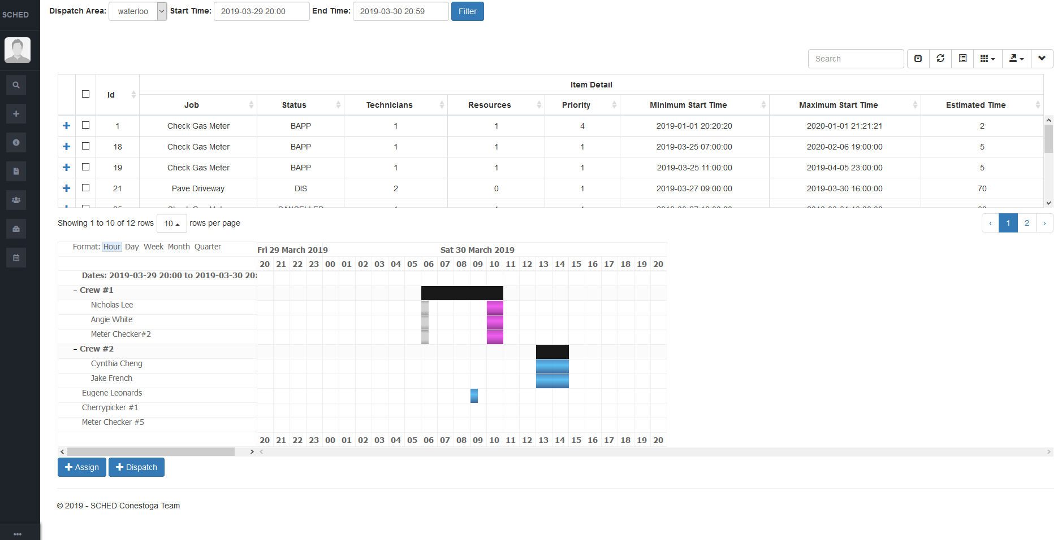

Sidebar

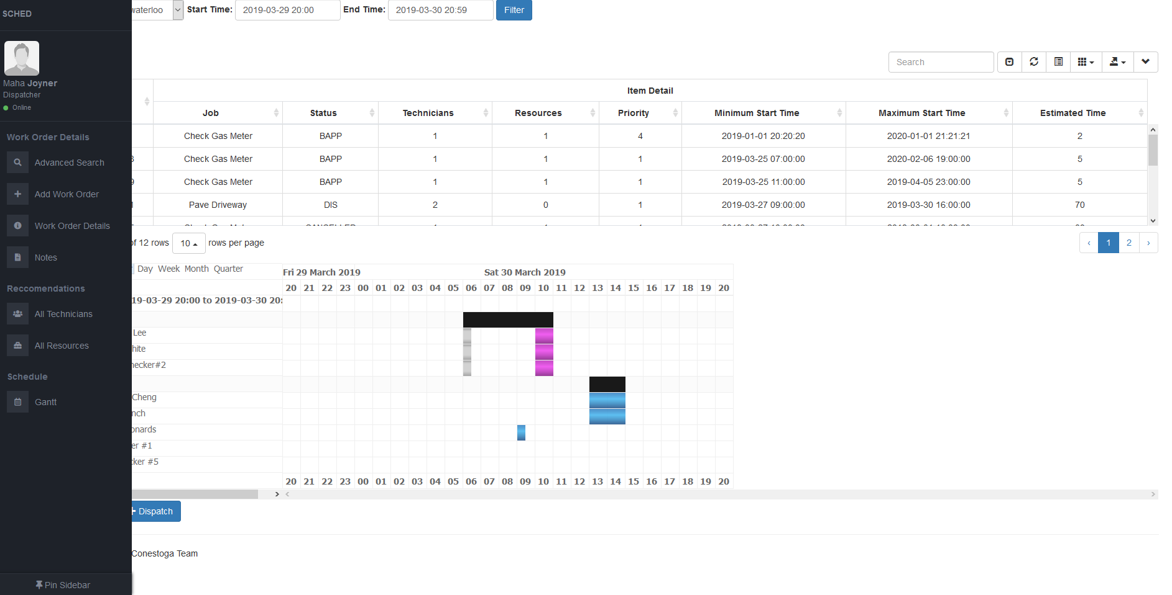

Selected Work Order – Displays Work Order Details, Work Order Notes, and Recommended Technicians/Resources

